**Chapter 8 – Team Project - Implementing Security Features for the Team Project**

*Submit this document with your answers, DDL statements, SQL*Plus screenshots, and Microsoft Visio screenshots. Do not change the order of the questions. Do not remove anything from this document. Do not create a new document. Provide your answers inline. In addition to submitting this document, submit the original Microsoft Visio files that you used to create the authorization graphs Failure to submit these documents will result in no credit.*

*Before submitting, edit the file name by including your team number as a prefix.*

*Ex: Team Number - Chapter 8 Team Project.docx*

*Follow the same format for any additional files that you submit.*

*Note: Do not submit zip files or pdfs.*

Read the sample project steps for this chapter and use it as a model in carrying out the steps for your team project. Use the normalized purely relational database you created at the end of chapter 6. For the team project, do the following:

**Step 8.1 – Step 8.4 - Database Security Features for the Team Project.**

For each step:

- Write out the SQL statements that will be executed in the database (in addition to showing the SQL Statements in the screenshot).

- Execute the SQL statements in the database and provide a single, continuous screenshot that demonstrates the results without interruptions. The screenshot should also include the current user ID, the current system date, the execution of the SQL statements in the database, and the results of the SQL statements. To display the current user and current date, run the following statement before running each SQL statement:

SQL> select user||' '||to_char(sysdate, 'DD-MON-YYYY HH24:MI:SS') from dual;

Note: Omitting the required information in any step may result in reduced points or no credit for that step.

**Step 8.1 – Design a value-independent view that hides some sensitive/private information. Indicate (write out) what sensitive/private information you are hiding from the value-independent view. Then create the value-independent view in the database.**

-- Create a masked view that protects sensitive member information

CREATE OR REPLACE VIEW masked_member_view AS

SELECT

memberID,

-- Hide member name: show only first initial and last name

SUBSTR(firstName, 1, 1) || '. ' || lastName AS masked_name,

-- Mask member phone number: show only last 4 digits

'***-***-' || SUBSTR(phoneNumber, -4) AS masked_phone,

-- Mask area code: show first 3 digits, rest masked

SUBSTR(areaCode, 1, 3) || '-***-****' AS masked_area_code,

-- Preserve non-sensitive location information

city,

state,

-- Preserve administrative information

dateJoined,

currentOfficeHeld,

-- Partially mask street address

CASE

WHEN LENGTH(street) > 0

THEN SUBSTR(street, 1, 5) || '***'

ELSE street

END AS partial_street

FROM Member;

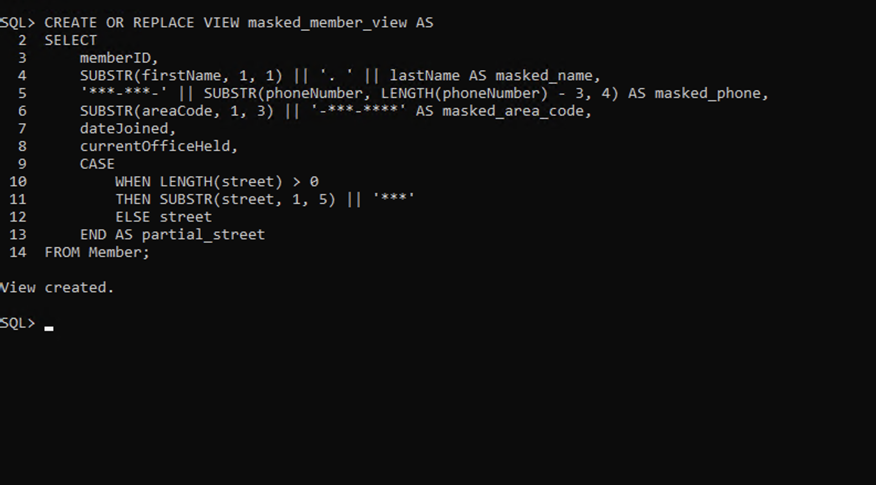

**Step 8.2 - Create a user and authorize that person to read the view. Connect to the database as the new user and demonstrate (provide screenshots) that the new user can read the view. Using Microsoft Visio, draw an authorization graph showing the privileges given.**

Note: Hand-written authorization graphs are not acceptable submissions.

Note: For authorization graphs, use the guidelines presented in Section 8.7 (SQL Data Control Language) and Figure 8.6 (An Authorization Graph) of the textbook.

-- Create a new user with view access

CREATE USER member_viewer IDENTIFIED BY viewer_password;

-- Grant connection privileges

GRANT CONNECT TO member_viewer;

-- Grant select privileges on the masked view

GRANT SELECT ON masked_member_view TO member_viewer;

-- Revoke direct table access

REVOKE SELECT ON Member FROM member_viewer;

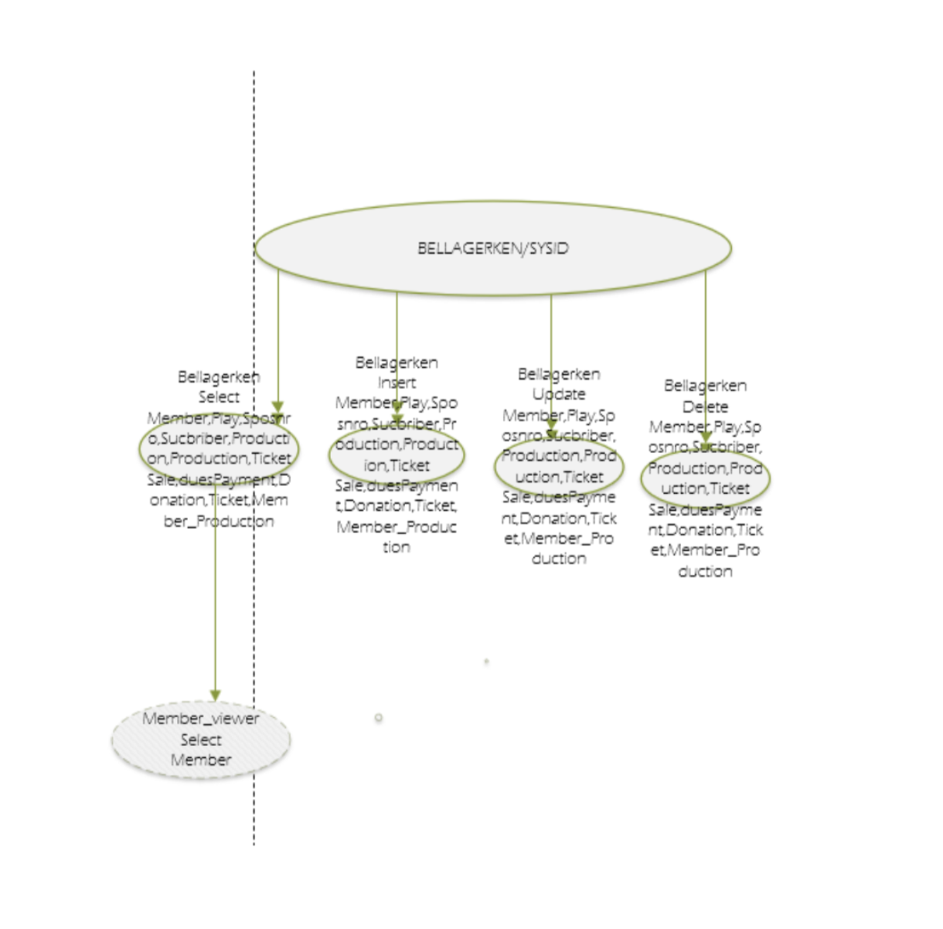

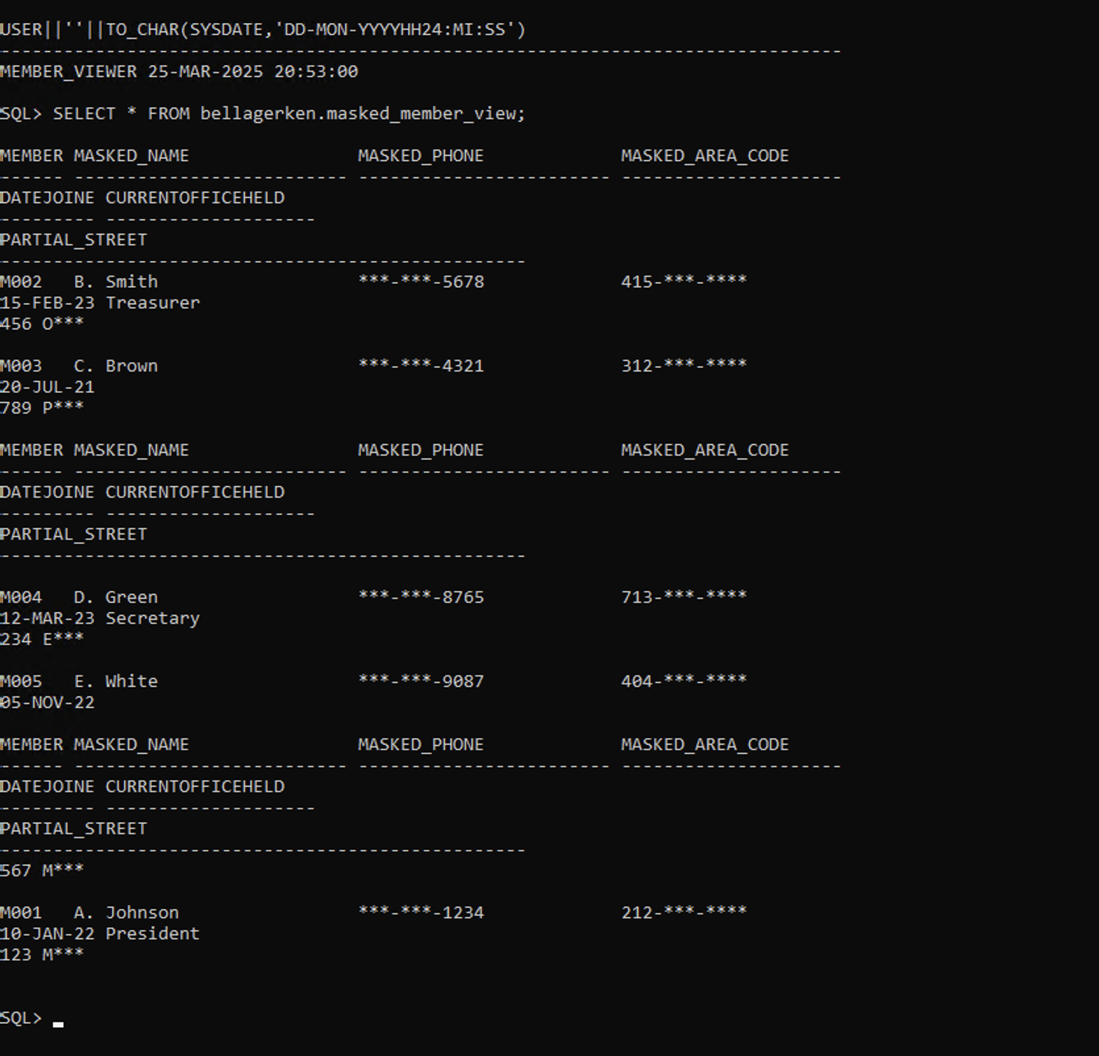

**Step 8.3 – Create and authorize four other users to access/modify different parts of the database. For each new user, connect to the database and demonstrate (provide screenshots) that each new user can access/modify the different parts of the database that you granted. Using Microsoft Visio, update the authorization graph showing the privileges given.**

Note: Hand-written authorization graphs are not acceptable submissions.

CREATE USER data_viewer IDENTIFIED BY viewer_password;

CREATE USER data_editor IDENTIFIED BY editor_password;

CREATE USER finance_user IDENTIFIED BY finance_password;

CREATE USER production_manager IDENTIFIED BY manager_password;

GRANT CREATE SESSION TO data_viewer;

GRANT CREATE SESSION TO data_editor;

GRANT CREATE SESSION TO finance_user;

GRANT CREATE SESSION TO production_manager;

GRANT SELECT ON bellagerken.MEMBER TO f;

GRANT SELECT ON bellagerken.PRODUCTION TO data_viewer;

GRANT SELECT ON bellagerken.PERFORMANCE TO data_viewer;

GRANT SELECT ON bellagerken.TICKETSALE TO data_viewer;

GRANT SELECT, INSERT, UPDATE ON bellagerken.SPONSOR TO data_editor;

GRANT SELECT, INSERT, UPDATE ON bellagerken.SUBSCRIBER TO data_editor;

GRANT SELECT, INSERT, UPDATE ON bellagerken.TICKET TO data_editor;

GRANT SELECT, INSERT, UPDATE ON bellagerken.TICKETSALE TO data_editor;

GRANT SELECT, INSERT, UPDATE ON bellagerken.DONATION TO finance_user;

GRANT SELECT, INSERT, UPDATE ON bellagerken.DUESPAYMENT TO finance_user;

GRANT SELECT, INSERT, UPDATE ON bellagerken.TICKET TO finance_user;

GRANT SELECT, INSERT, UPDATE ON bellagerken.PLAY TO production_manager;

GRANT SELECT, INSERT, UPDATE ON bellagerken.PRODUCTION TO production_manager;

GRANT SELECT, INSERT, UPDATE ON bellagerken.PERFORMANCE TO production_manager;

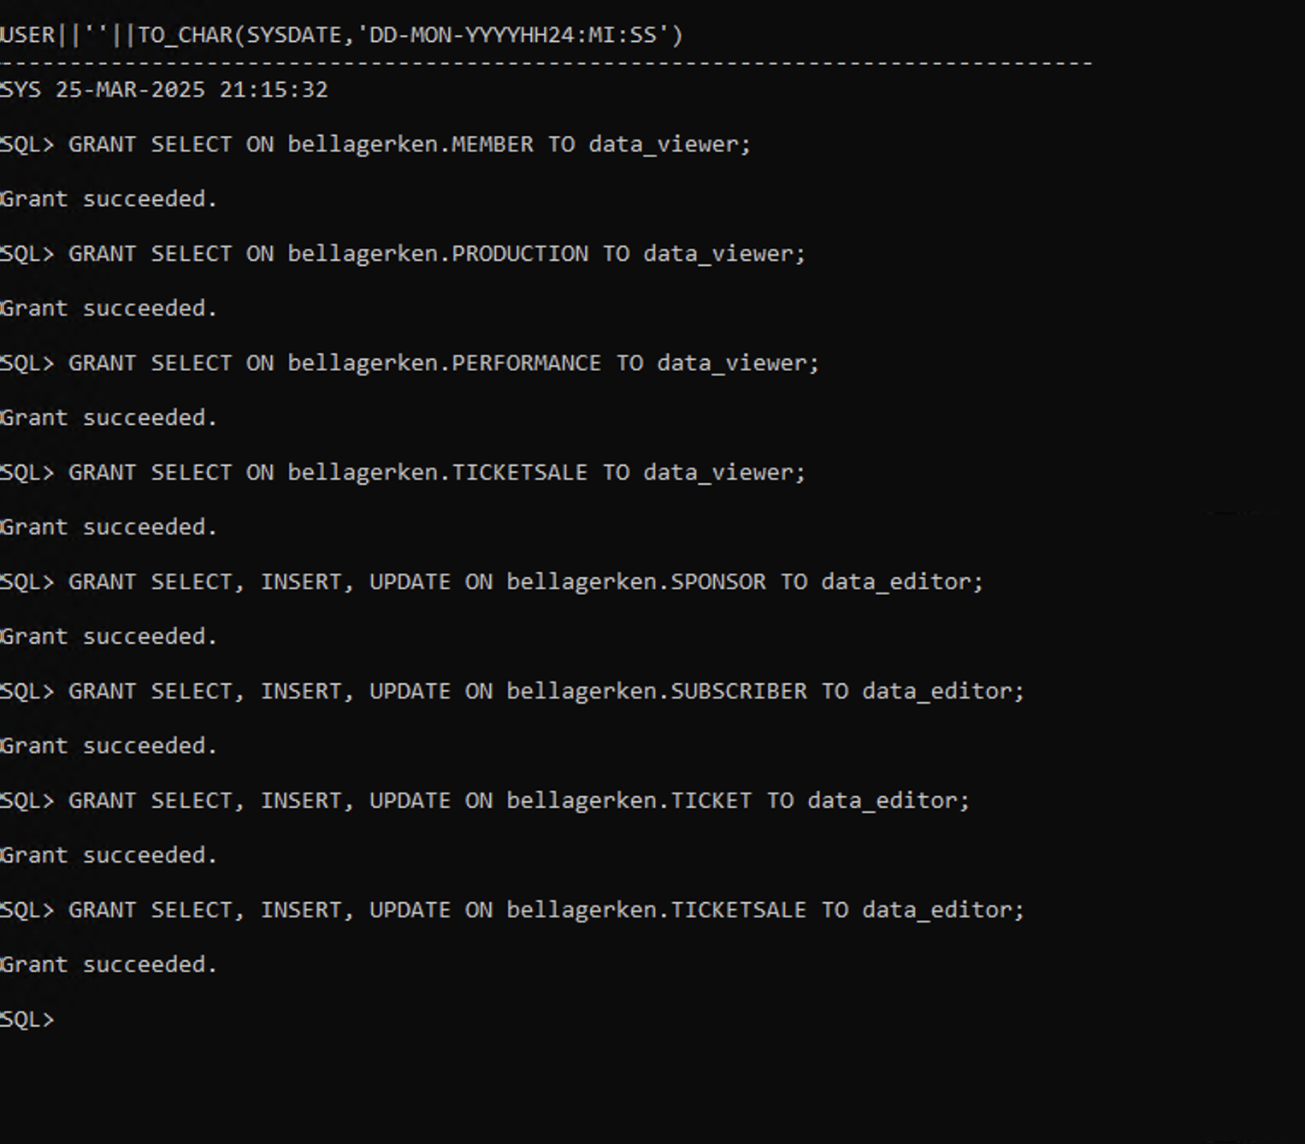

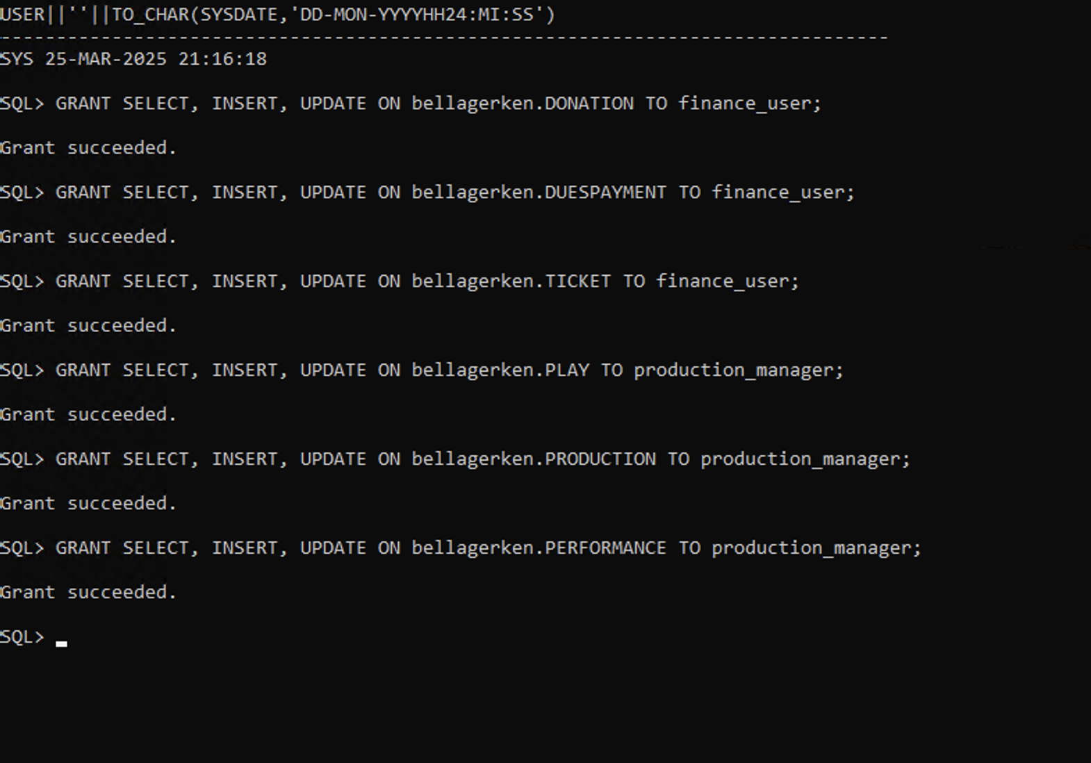

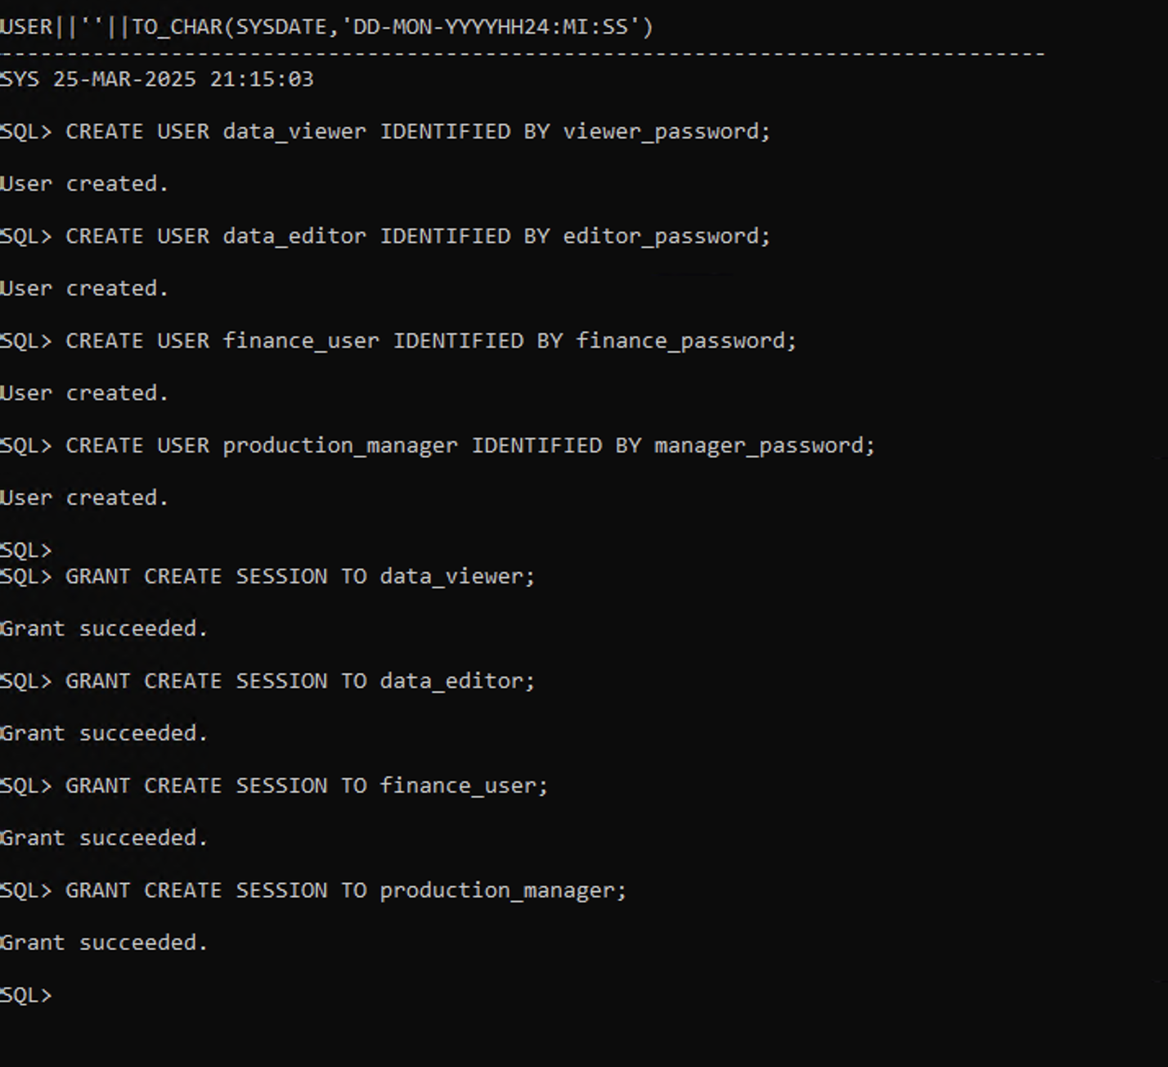

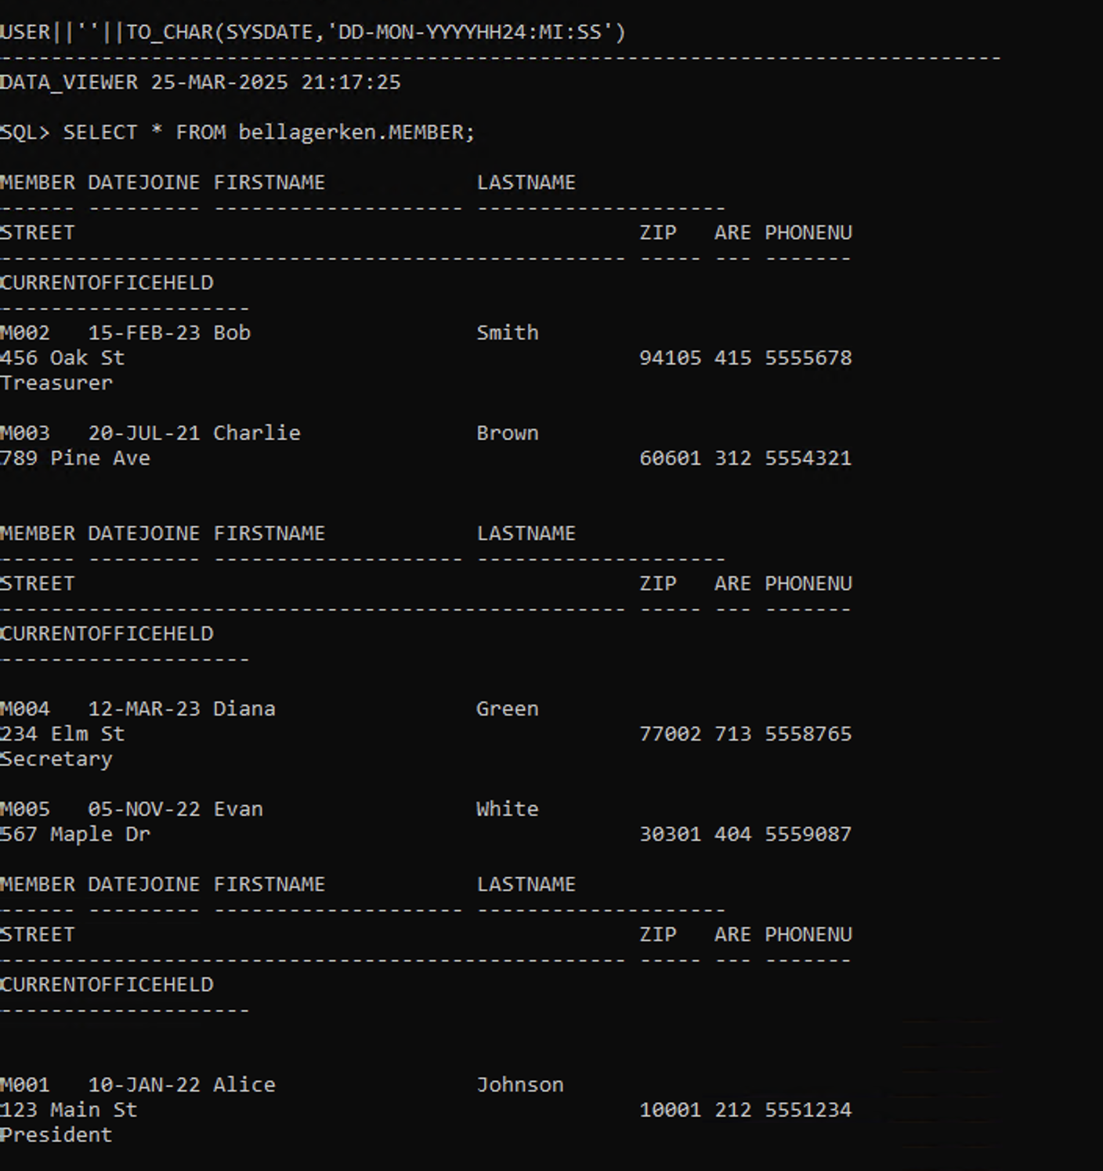

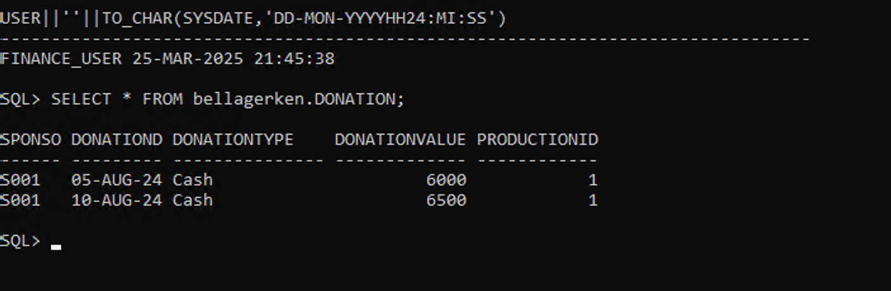

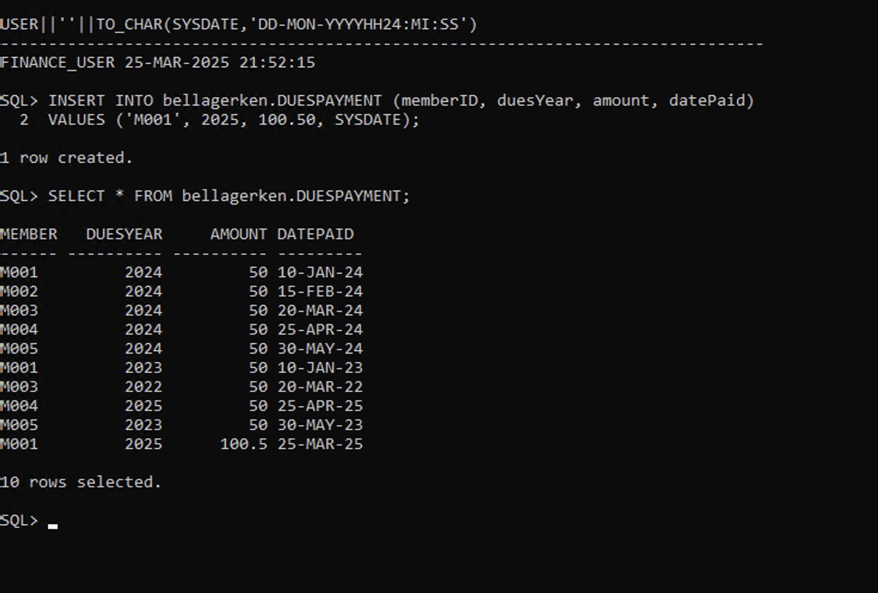

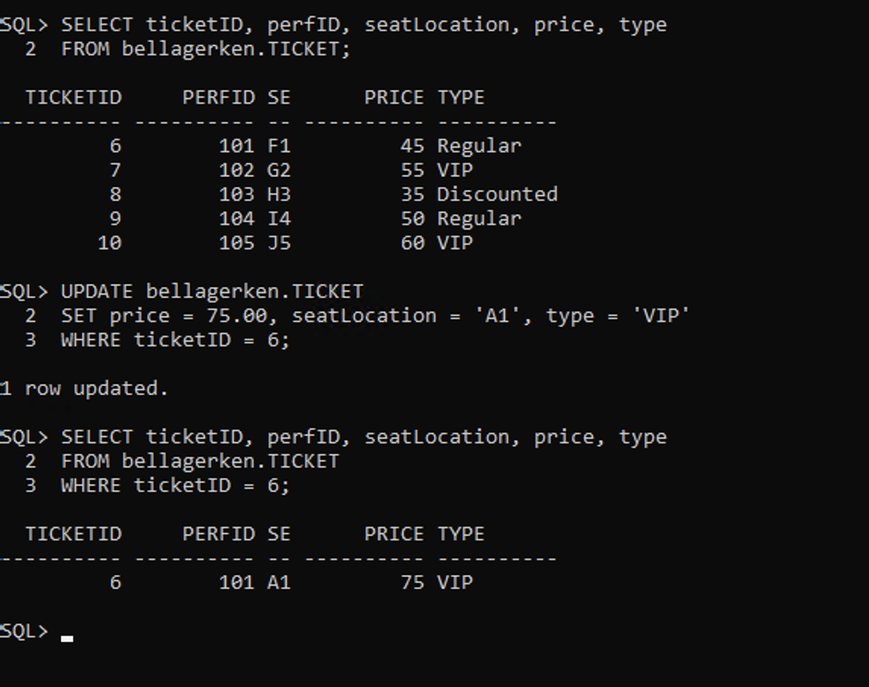

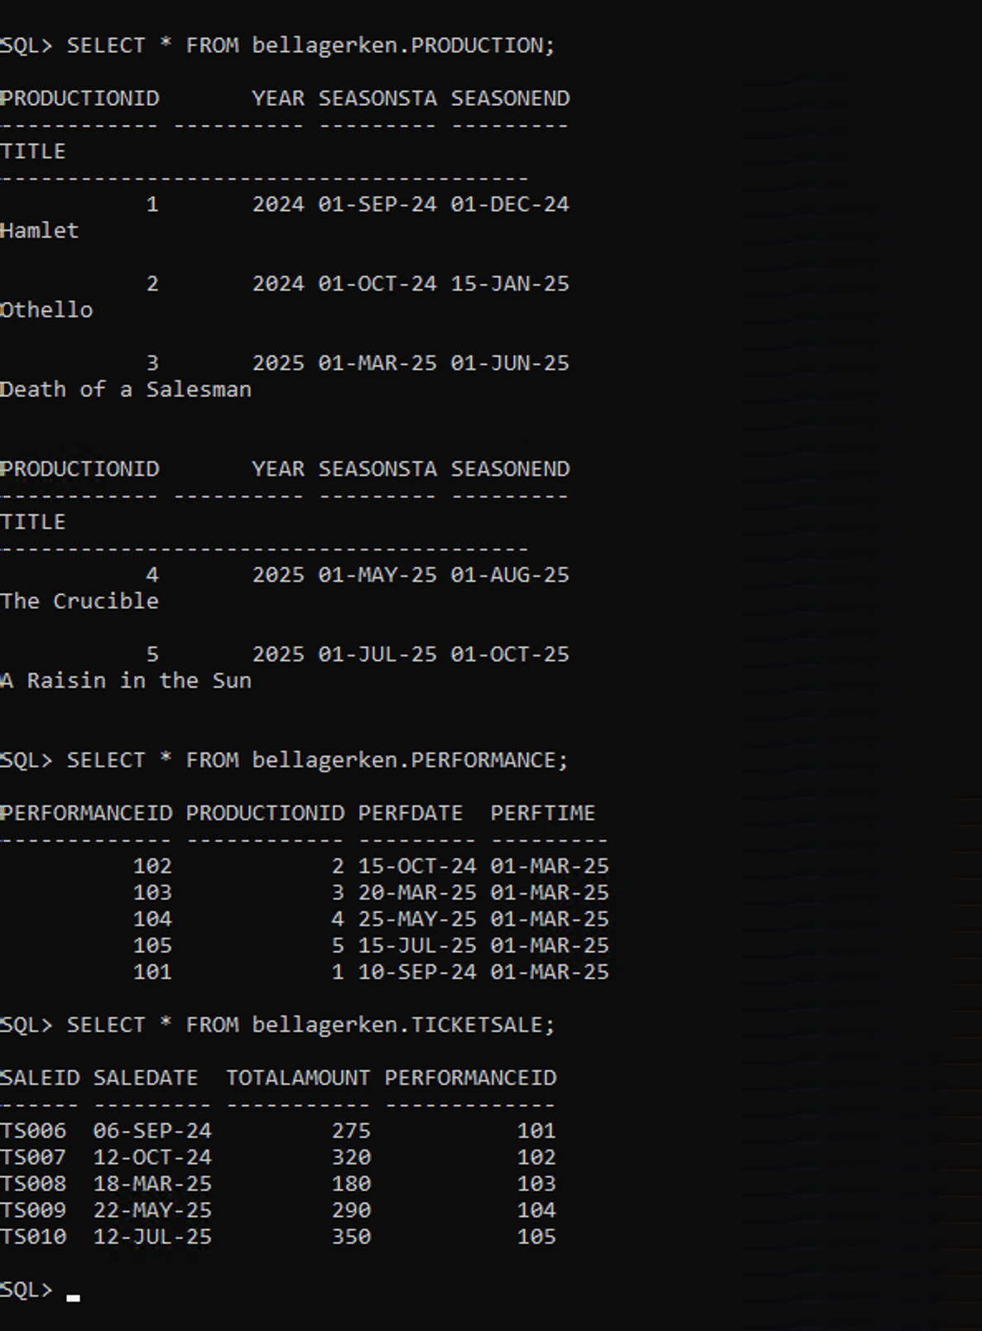

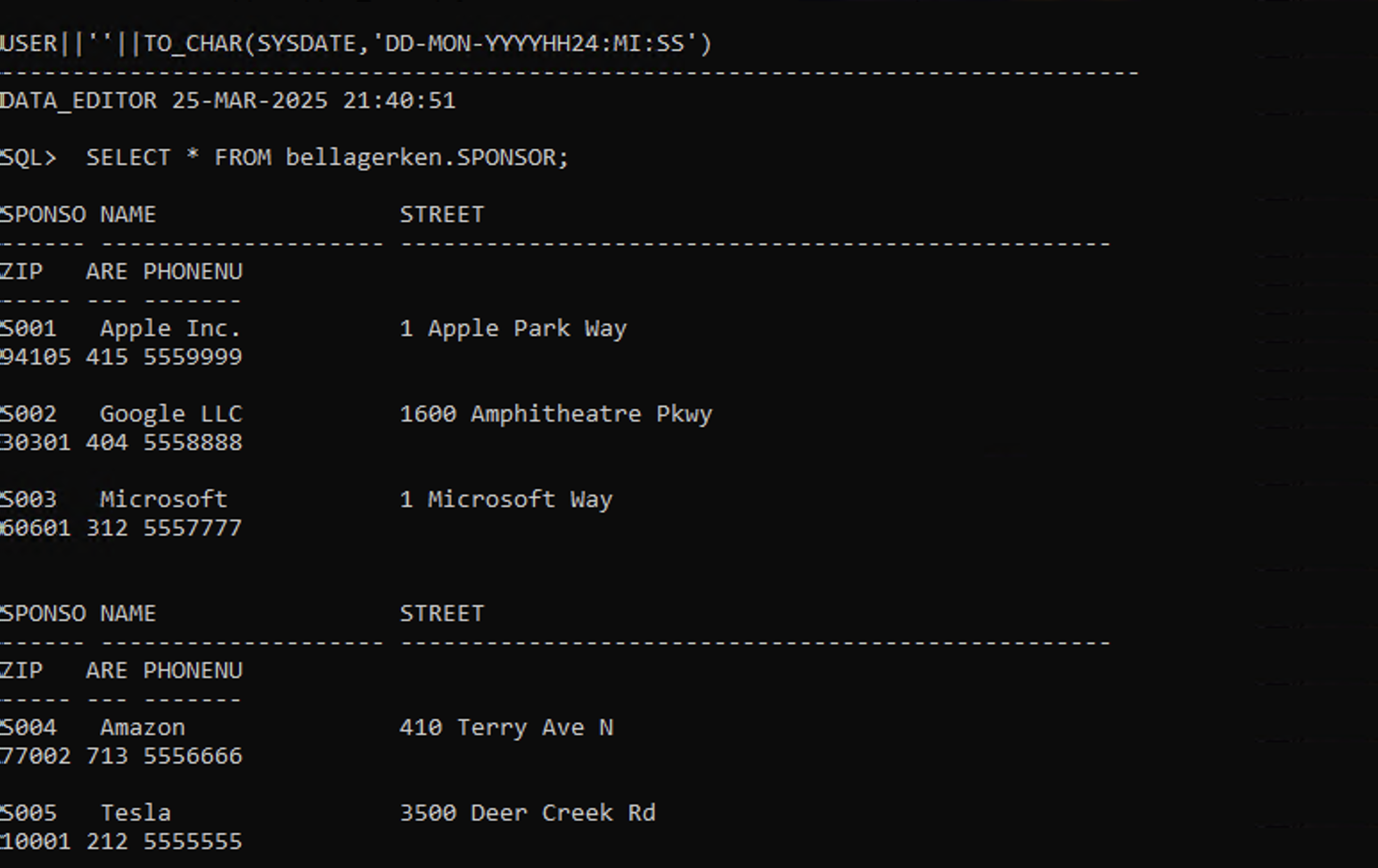

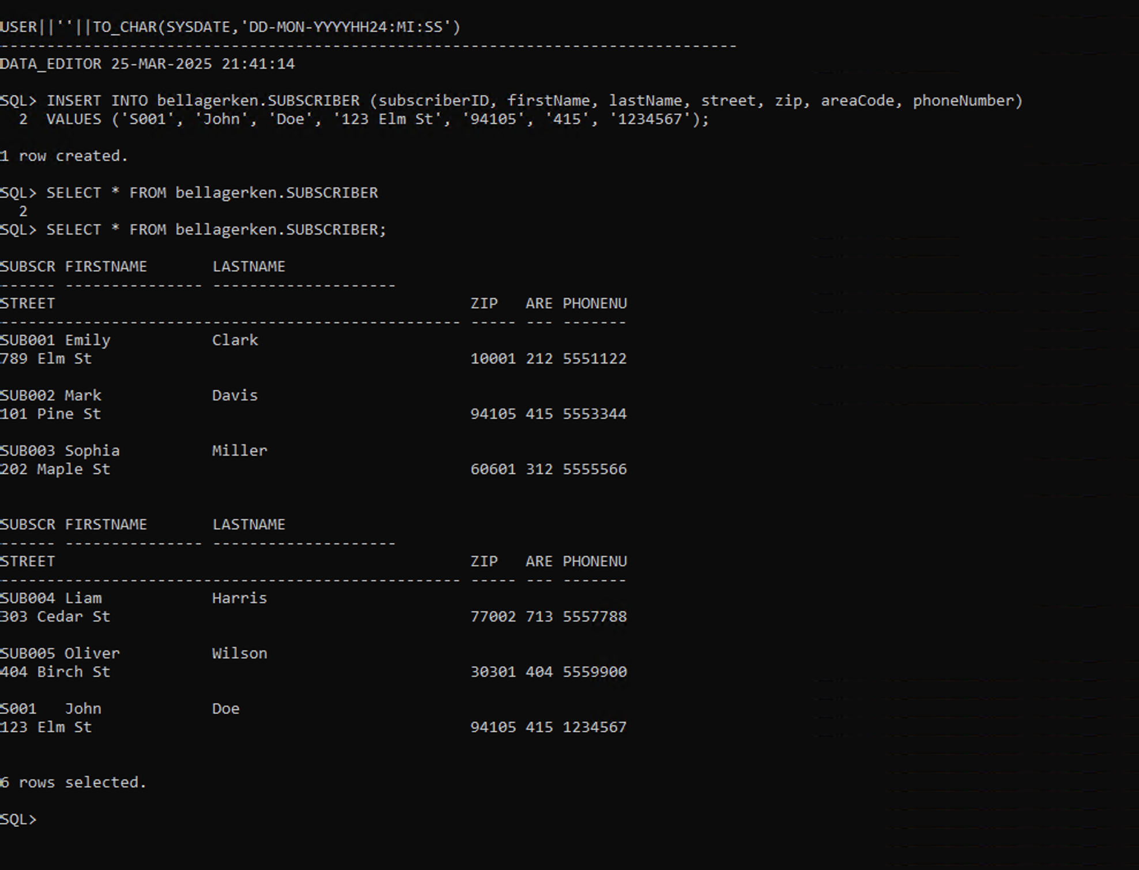

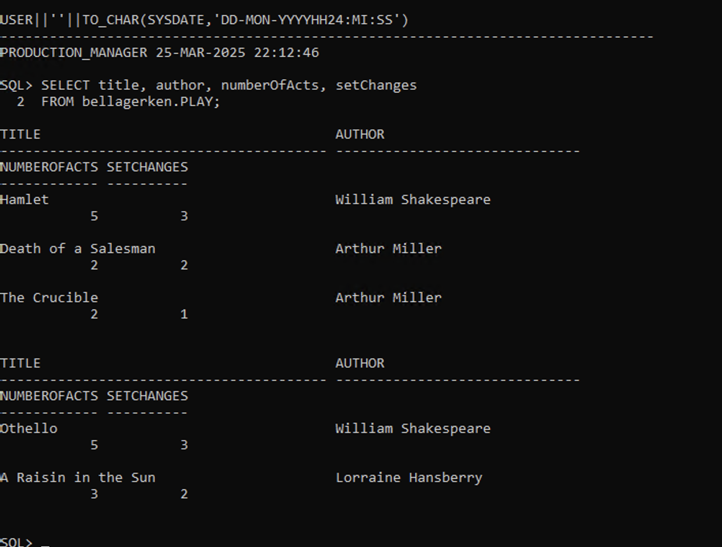

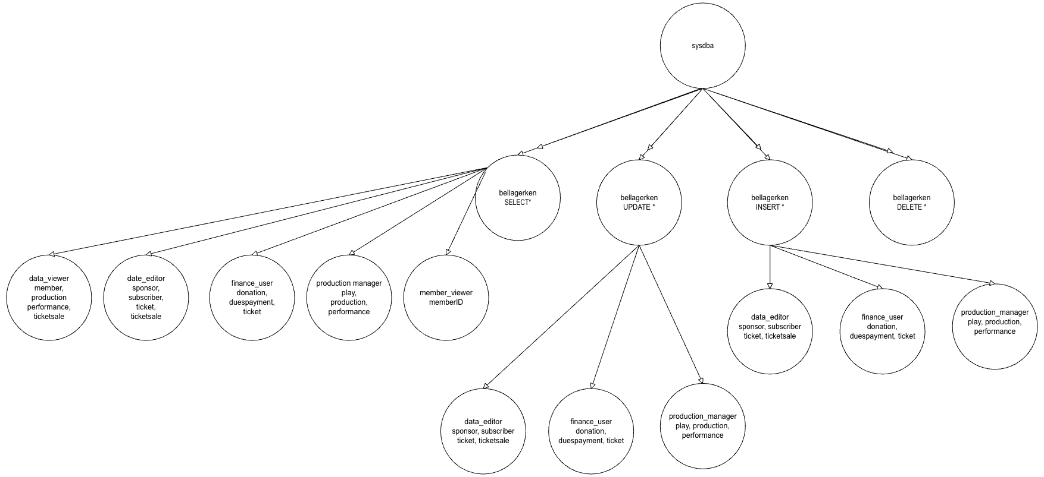

**Step 8.4 - Design an audit trail table and an audit trail trigger for updates to a sensitive/private item. Then create the audit trail table and audit trail trigger in the database.**

**Then design and execute SQL statements to demonstrate that the trigger is working as expected.** To demonstrate that the trigger is working as expected, provide a single, continuous screenshot of the data before and after the trigger is executed.

Note: The audit table must include all attributes of the main table, and the trigger should capture the entire row upon updates. This ensures complete tracking of changes, allowing for the reconstruction of the original record at any time.

CREATE TABLE bellagerken.member_audit (

audit_id NUMBER GENERATED ALWAYS AS IDENTITY PRIMARY KEY,

memberID VARCHAR2(6),

firstName VARCHAR2(20),

lastName VARCHAR2(20),

street VARCHAR2(50),

zip CHAR(5),

areaCode CHAR(3),

phoneNumber CHAR(7),

dateJoined DATE,

currentOfficeHeld VARCHAR2(20),

changed_by VARCHAR2(50),

change_date DATE DEFAULT SYSDATE,

operation VARCHAR2(10)

);

CREATE OR REPLACE TRIGGER member_audit_trail

AFTER UPDATE ON bellagerken.MEMBER

FOR EACH ROW

BEGIN

INSERT INTO bellagerken.member_audit (

memberID, firstName, lastName, street, zip, areaCode, phoneNumber, dateJoined, currentOfficeHeld,

changed_by, change_date, operation

) VALUES (

:OLD.memberID, :OLD.firstName, :OLD.lastName, :OLD.street, :OLD.zip, :OLD.areaCode, :OLD.phoneNumber,

:OLD.dateJoined, :OLD.currentOfficeHeld, USER, SYSDATE, 'UPDATE'

);

END;

SELECT * FROM bellagerken.MEMBER WHERE memberID = 'M001';

UPDATE bellagerken.MEMBER

SET firstName = 'Alice', lastName = 'Smith', phoneNumber = '7654321'

WHERE memberID = 'M001';

SELECT * FROM bellagerken.MEMBER WHERE memberID = 'M001';

SELECT * FROM bellagerken.member_audit ORDER BY change_date DESC;

